Apparel Chain Market Analysis

Executive Summary
The company has been experiencing lackluster sales and has requested a market analysis to inform a data-driven marketing campaign to recapture customers. The chart below clearly indicates that total sales are in decline; however, the recent increase in average purchase amounts is a promising signal that customer spending habits may be shifting toward larger transactions. The company can capitalize on this trend by maximizing reach, thereby regaining total sales growth.
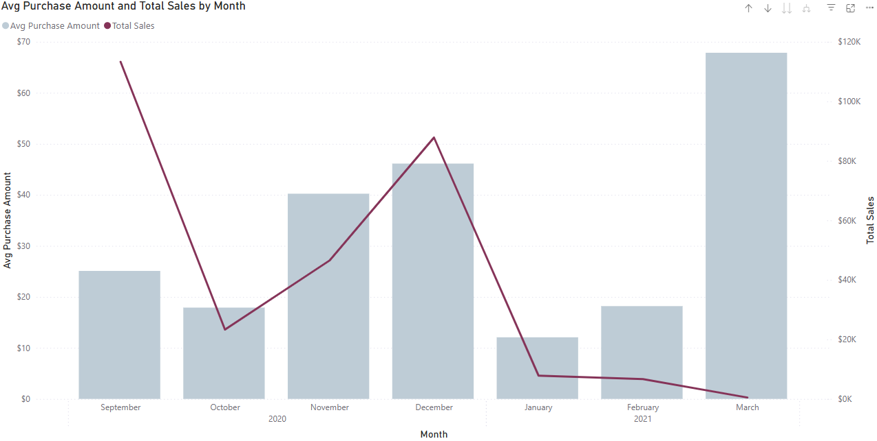
In the interest of maximizing reach, we have analyzed internal and external data including:
- company customer base (purchase history, location, demographics)
- company inventory (products, ratings, return rates, stock quantities, prices)
- state demographics (average income, industry populations)
- BLS age demographics data (age ranges, average income, average apparel spend)
Findings and key insights along with supporting data visualizations follow.

Analysis & Findings
- The R² Correlation Coefficient of Average Income by State and Average Sales by State is calculated as 0.78, indicating a strong positive linear relationship between the two variables. For the purposes of this analysis, we aim to use this relationship to predict customer incomes based on purchase history, allowing for more intelligently targeted advertising.
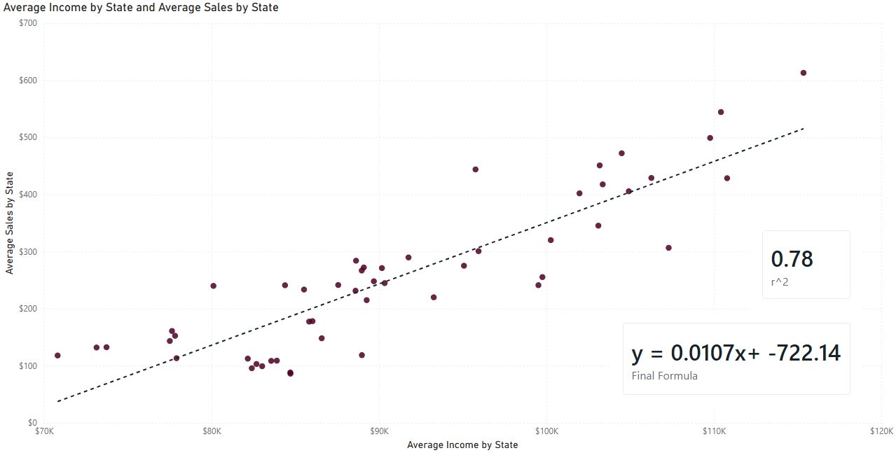
  - y = Average Salary by State
  - x = Average Income by State
  - Final Formula: y = 0.0107x + -722.14
- The Linear Regression Formula used to predict customer income from customer sales: x = (b-y)/-m
  - n = 51 (number of states evaluated)
  - b = yx^2 – x*xy / nx^2 - x^2
  - m = n*xy – xy / nx^2 – x^2
- The R² Correlation Coefficient between customer ratings and product return rate is calculated as 0.69, indicating another significant correlation. As visualized in the scatterplot below, this can be viewed as a strong negative correlation, where product returns decrease linearly as customer ratings increase. This means that we can operate with some confidence on the prediction that products with higher customer ratings are less likely to be returned, and will therefore contribute to higher net sales.
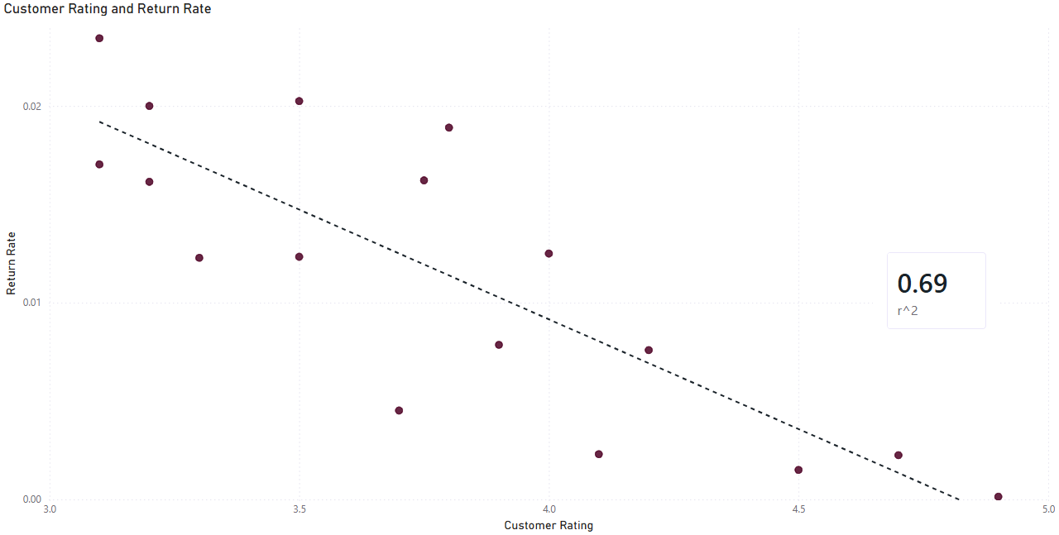
- The resulting predicted incomes were then sorted into bins and used to populate a histogram to visualize the distribution of expected incomes among the company’s customer base.
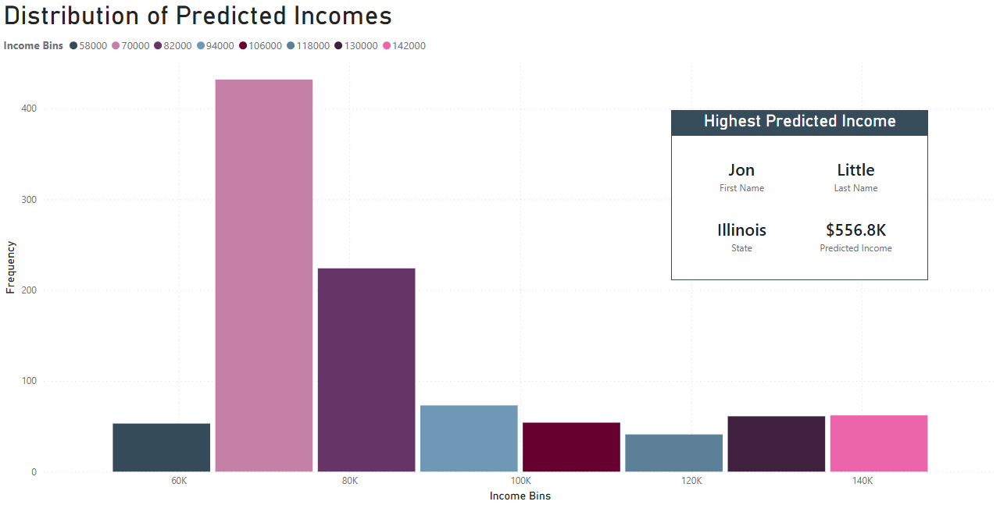
The distribution is significantly right-skewed, indicating a majority of customers falling into the expected income range of $70k - $94k, with a minority of customers having far higher expected incomes. The customer with the highest predicted income is denoted as Jon Little from Illinois with an expected income of nearly $557k based on purchase history.

Marketing Recommendations
- After sorting the expected incomes into histogram bins as reviewed above, each range was assigned to a proportionate segment of products based on pricing. This analysis recommends the following general, targeted, and regional marketing strategies based on expected incomes calculated for the customer base:
  - General: advertising should be most focused on products that have:
    - High number in stock, to maximize potential sales volume
    - Higher price point, to maximize potential total sales
    - High customer rating, to minimize returns/refunds
  - Targeted: products should be marketed to demographics matching income/spend bins as shown below for the three main products of interest for this analysis:
    - Shirt: $25
    - Sweater: $100
    - Leather Bag: $1,000
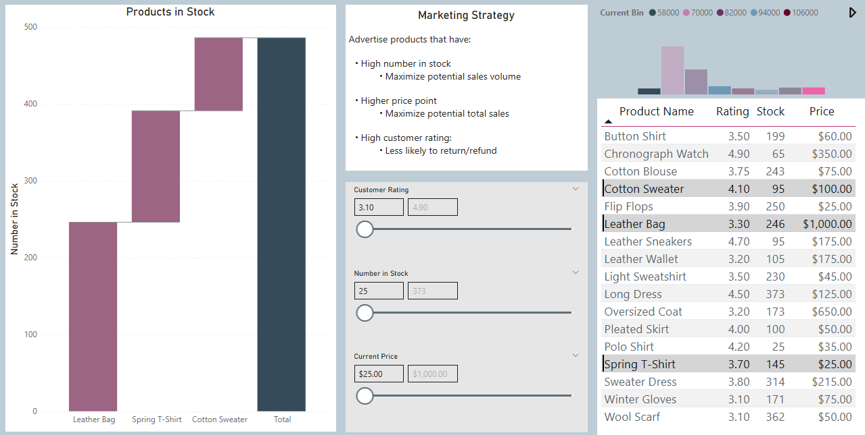
Once the three products of interest are selected from the table, their corresponding histogram bins are highlighted and can drill-through to the Average Income by State Heatmap, as shown below for each item in descending price order.
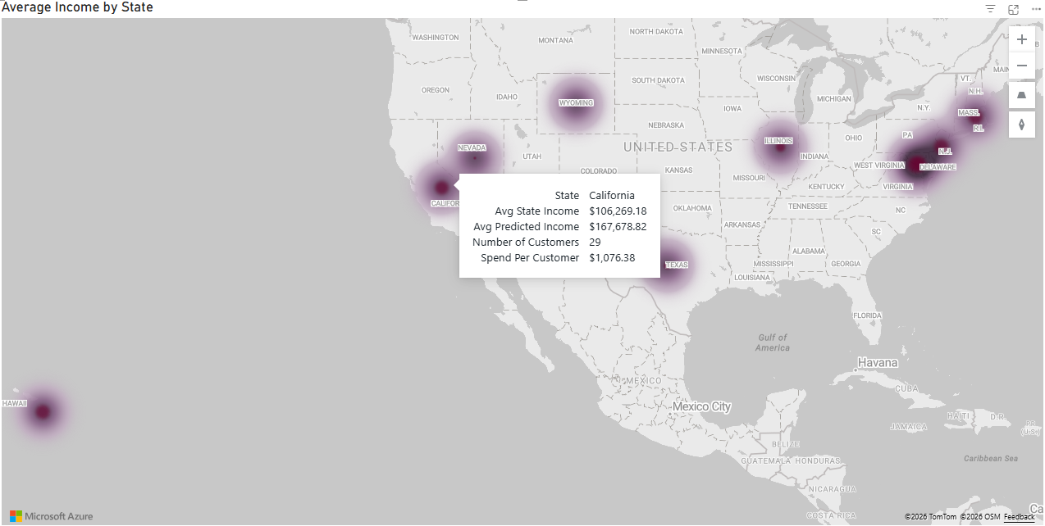
Leather Bag: $1,000
- This is the most expensive item in inventory, limiting its target demographic. The price range aligns with a roughly 10 customers in the northeast, 5 in Illinois, 10 in Texas, and nearly 30 in California, all states with high rates of spend per customer. Reaching only half of these customers (for instance, reaching all indicated Clifornia customers) would result in $27k in sales. Unfortunately, the stock is very high for this product, and the customer rating is lackluster. The company will need to expand marketing in high income areas to grow the high-spend customer base to move the large quantity on hand, and may experience some returns due to low customer satisfaction with the product. Using the heatmap to highlight states with average income greater than $105K, the northeast region is indicated as the region of interest toward this goal, especially Maryland, New Jersey, and Massachussetts.
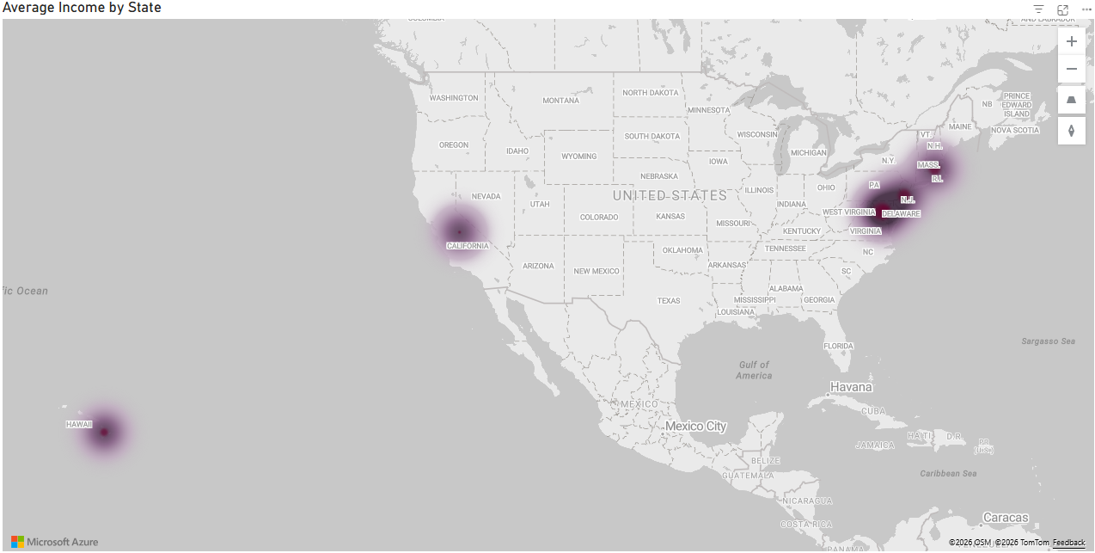
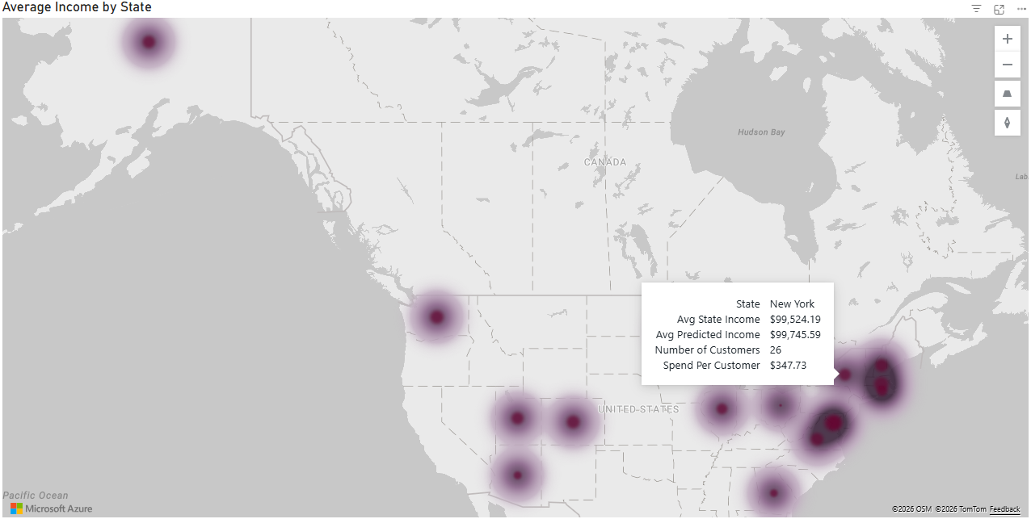
Sweater: $100
- Of the three products of interest, the Sweater has the highest potential to sustainably grow sales. This item has a much broader alignment over many states, with New York indicated as the most fruitful area for advertising. The Sweater also has a very high customer rating, meaning that returns are unlikely, and the stock is appropriate for the potential demand. Correctly targeting the marketing for this item could lead to over $9K in retained sales.
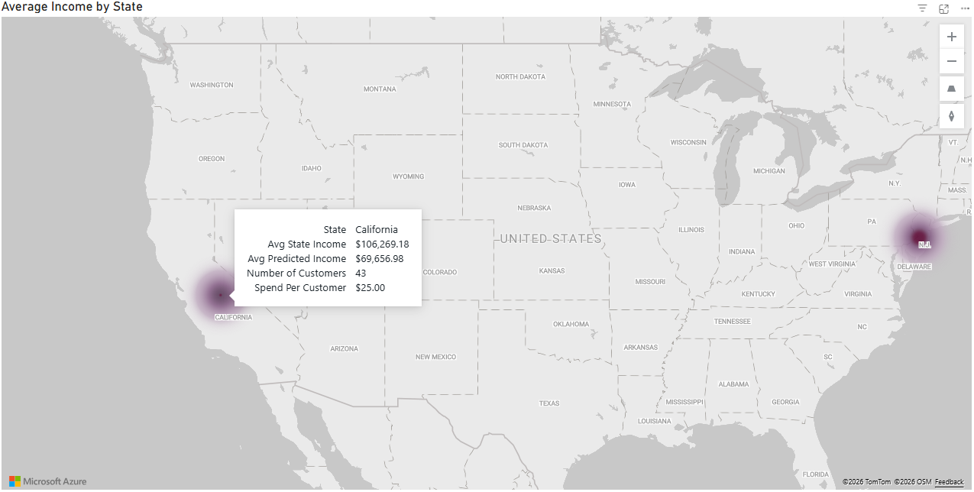
Shirt: $25
- The T-Shirt is a moderately rated, low-priced utility item that is aligned with the lowest income tier in the customer base. New Jersey and California are indicated as states of interest for marketing the T-Shirt, with California expected to perform better due to a larger customer base.
  - Regional: cast a wide net, growing the customer base by advertising in states where potential is highest for total annual apparel spend based on state average income and BLS age demographics data.
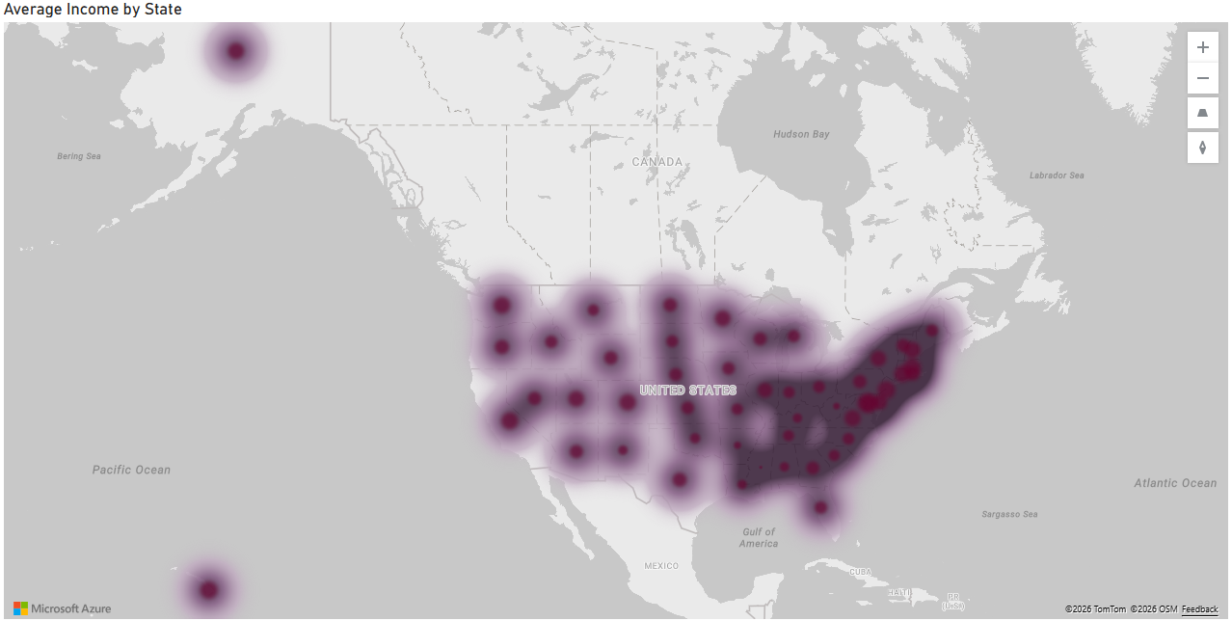
Using the heatmap again to detect regions with high income (and therefore expected high purchase amounts), the coastal northeastern states are identified as ideal for expansion.
To enrich our roster of areas of interest for expansion, we also introduce age demographic data to evaluate expected apparel spend based on existing customer base age ranges. The below report distills this data into a few panes for exploration, breaking down sales by state and age domain.
Key Insights:
    - California is by far the greatest state contributor to sales, the source of over $64K in sales out of $286K total over the period. Overall, CA has an average historical spend per customer of $429, and an estimated total apparel expenditure of $283K just within the existing customer base. California also has strong representation of the top 3 age ranges for annual apparel spending:
      - 35-44 yrs: $2,156
      - 45-54 yrs: $2,068
      - 25-34 yrs: $1,863
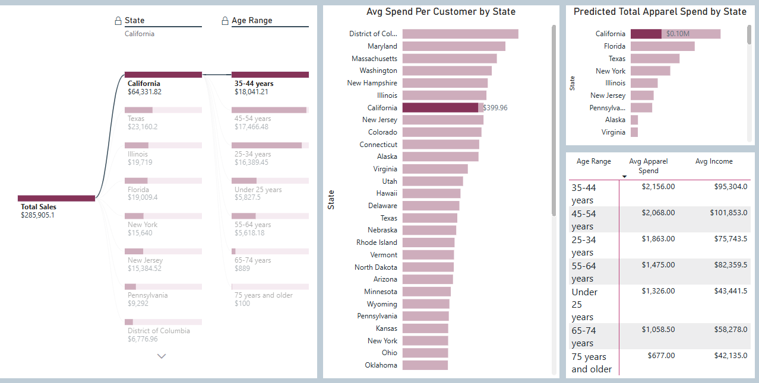
- Top states for sales historically, following CA: Texas, Florida, Illinois, New York, New Jersey
- These top states line up exactly with the top states for predicted apparel spend based on age demographics.
This analysis and supported recommendation can be utilized to form a data-driven campaign to reverse recent sales downturns and expand the company’s customer base. See the attached report for more in-depth visual exploration of the data.

Additional data sourced from: https://www.bls.gov/cex/tables/calendar-year/mean-item-share-average-standard-error.htm

